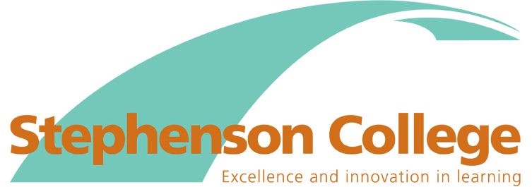

Equality Objectives 2016-2020

Equality Objective 1

To seek to attract, develop and retain a more diverse workforce, reflective of the College’s local and wider community.

We will seek to achieve this by:

- Ensuring fair, transparent and supportive recruitment procedures that recognise the barriers that can be faced by diverse groups

- Ensuring that recruiting managers receive appropriate recruitment and selection training

- Regularly collecting and analysing recruitment and workforce monitoring data and developing strategies to address any identified barriers or under-representation from particular groups compared with the 2011 census data

- Ensuring that the College’s Pay and Remuneration Policies are based on fair and transparent criteria and that the College conducts regular pay audits

- Providing training and professional development to ensure that all staff are knowledgeable and equipped to meet the diverse needs of students and confidently implement equality of opportunity in their everyday practice

- Enabling lecturers to develop a range of teaching strategies that actively promote equality and celebrate diversity

Equality Objective 2

To support access to learning for different groups of students.

- Developing our ‘Student Voice’ strategies to ensure that they are inclusive, support participation and are influential in improving outcomes for students.

- Ensuring that our admissions processes enable all students to access information, advice and guidance to make informed choices and to be considered for courses and/or training on an equal and consistent basis.

- Ensuring all our students are supported to achieve their full potential irrespective of learning need or disability
Equality Objective 3

To ensure that all members of the College community promote, advance and celebrate equality and diversity and our shared values

We will achieve this by:

- Promoting learning and working opportunities to challenge occupational, curriculum and wider cultural stereotypes

- Ensuring that equality, diversity and our shared values are an integral part of the student induction and that students are aware of their rights and responsibilities and how to seek help and support in relation to issues of harassment and or discrimination

- Ensuring that equality and diversity and shared values are embedded into our teaching, learning and assessment practice and that we provide opportunities for students to discuss sensitive and sometimes controversial issues in a safe environment.

- Continuing to support national agendas around increasing the proportion of females in construction

Equality Objective 4

To ensure that attainment gaps are minimised and that all programmes lead to strong and sustained progression into employment, further or higher education for all groups of students

We will achieve this by:

- Regularly collecting and analysing student retention and achievement data and developing strategies to address any identified attainments gaps from particular groups of students

- Regularly collecting and analysing students destination data and developing appropriate strategies to ensure all students acquire the skills they need to make the successful next step

- Providing high quality work experience for students across all programmes

